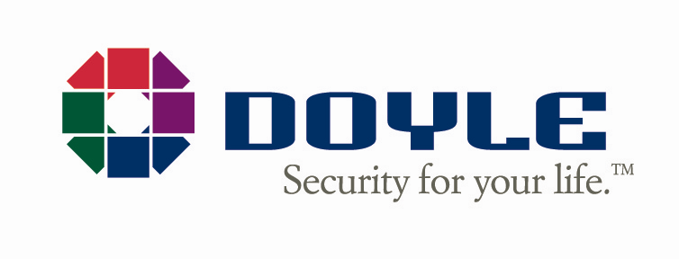

February 7, 2025

Dear Valued Customer of Notifier of New York,

# On behalf of our entire team, I would like to welcome you to the Doyle Security Systems Family!

The Notifier of New York team joined forces with Doyle on February 7, 2025. Just like Notifier of New York, we are a New York based company with operations in the greater Syracuse area. We are excited and honored to continue to provide you with the highest quality protection and great service you received from Notifier of New York.

Let us get to know each other! It is worth noting that Notifier of New York and Doyle Security Systems have a lot in common. Both of our companies are well known in our industry for providing premiere service. Doyle is also a certified Notifier ® by Honeywell Dealer. We are eager to tell you about some new features and benefits you will receive from our team at Doyle Security:

* An award-winning Emergency Response Center that is both UL-Listed, Five Diamond Certified, and wholly owned and operated by Doyle, no 3rd parties.
* An experienced staff that receives the highest level of training available for our industry.
* A team of Emergency Response Center supervisors who average more than 10 years with our company and are always ready to be at your service.
* The very latest technology and capability in commercial and residential systems, including fire, intrusion, video, access, medical alarms and home automation.
* A family-owned business that is Great Place to Work Certified.

Doyle Security has been family-owned and operated since 1919, so you can rest assured that our experience in the security industry will provide you the best protection available. In addition to our Syracuse location, we have offices in Albany, Buffalo, Rochester, Fishkill, Olean, Catskill, Dunkirk and Watertown, New York as well as Erie, Pennsylvania. We have worked tirelessly for more than 100 years to ensure that our customers receive the best possible security with the greatest reliability available in our industry!

If you have any questions, please do not hesitate to contact us at any of the support options we have included below. You can also receive periodic updates about the merger by filling out the form on our website at www.godoyle.com/notifierofny.

Again, we are thrilled to welcome you to our Doyle Security family, and we look forward to protecting what’s important to you!

Sincerely,

**Jack Doyle,**

**President & CEO**

**Customer Support:**

**NotifierSupport@GoDoyle.com**

**www.GoDoyle.com/NotifierofNY**

**Phone: (877) 719-6350**